A000-Mex-Olmec-El Mirador-Celt-Jade-1100 BCE

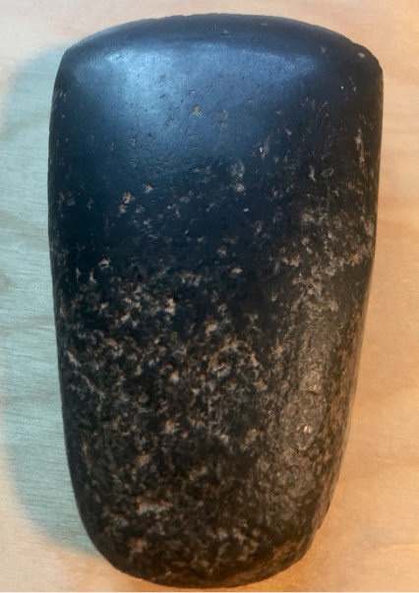

Mex-Olmec-El Mirador-Celt-Jade-1100 BCE

**Case No.: 10**

**Accession No.**

**Formal Label:** Mex-Olmec-El Mirador-Celt-Jade-1100 BCE

**Display Description:** The jade appears black but it also has tiny traces of green in it. Originated from El Mirador site in Guatemala, famous for Olmec and Mayan artifacts. Celts of this smaller size were commonly used as trade currency.

**LC Classification:**

**Date or Time Horizon:**

**Geographical Area:**

**Map:**

**GPS coordinates:**

**Cultural Affiliation:**

**Media:**

**Dimensions:**

**Weight:**

**Condition:**

**Provenance:**

**Discussion:**

**References:**

Approximately 55mm x 35mm.